Game Design Document

Fill up the Following document

1. Write the title of your project.

Ambulance – Onto to save the city.

1. What is the goal of the game?

Goal of the game is to signify the importance of the emergency services and create awareness among people regarding the importance of road safety

1. Write a brief story of your game?

The story is regarding hundreds of people that die every day due to late arrival of emergency services . This game creates simulation that how people should give way to emergency services so that lives are saved. This game will provide people with a sense of conduct and improve their skills of driving.



1. Which are the playing characters of this game?

* Playing characters are the ones which respond to the user based on the input from the user
* Cars, monkeys, dinos, wizards etc, are the playing characters in the game.

|  |  |  |
| --- | --- | --- |
| Number | Character Name | What can this character do? |
| 1 | Ambulance | Move through roads and stop when required. |
| 2 |  |  |
| 3 |  |  |
| 4 |  |  |
| 5 |  |  |
| 6 |  |  |
| 7 |  |  |
| 8 |  |  |

1. Which are the Non Playing Characters of this game?

* Non Playing characters are the ones which don't have an action or a behaviour when the user interacts with the game.
* Hurdles, stones, bananas, coins, etc are non playing characters in the game.

|  |  |  |
| --- | --- | --- |
| Number | Character Name | What can this character do? |
| 1 | Cars | They act as a obstacle which cause trouble in ambulance reaching the hospital. |
| 2 | Hospital | Destination |
| 3 | Pedestrians | Distraction for Ambulance |
| 4 |  |  |
| 5 |  |  |
| 6 |  |  |
| 7 |  |  |
| 8 |  |  |

Draw your imagination of this game. What does this game look like?

* Draw the game either on your computer or on paper,
* Add images of scenes of the game to show each of the playing and non-playing characters at least once.

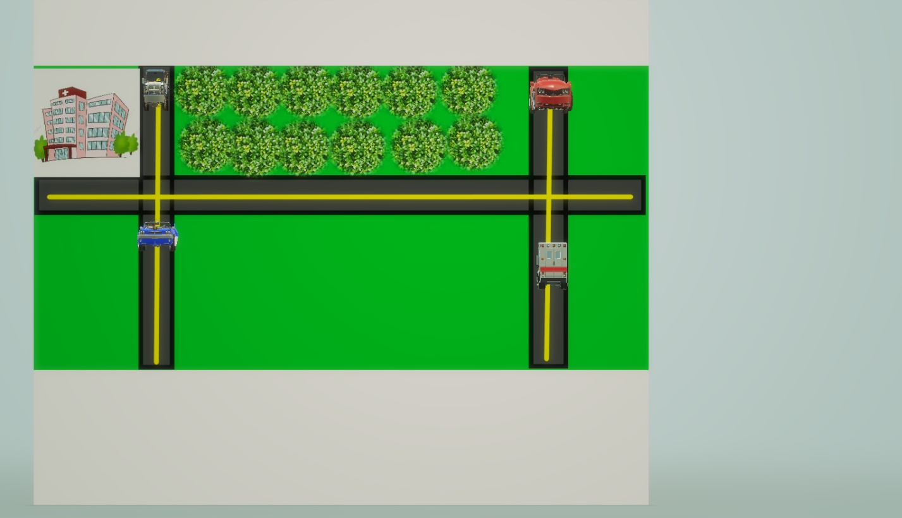

How do you plan to make your game engaging?

To develop interest this will game will have levels, as the person’s level increases he/she will get less time to reach the hospital or the distance between the hospital and starting position of ambulance will increase .